Conceptualization Document
04/21/15

Table of Contents

1.0 Introduction 3
1.1 Overview of Application 3
1.2 Project Objectives 5
1.3 Assumptions 6
1.4 Limitations 9
1.5 Open Items and Risks 10
2.0 Existing Business Flow 12
2.1 Overview 12
2.2 Context Diagram 14
2.3 High Level Workflow 15
2.4 Dependencies 16
2.5 Current Limitations/Problems 17
3.0 Proposed Workflow 18
3.1 Overview 18
3.2 Context Diagram 24
3.3 High Level Workflow 25
3.4 Use Case Diagrams 34
4.0 Business Requirements 37
4.1 Users 37
4.2 Inputs/Outputs 37
4.3 Dependencies 40
4.4 Task Requirements 42
4.5 Security Requirements 53
4.6 Performance Requirements 53
4.7 Data Migration 54

Introduction

Overview of Application
The customer of this project is the NASA Nutritional Biochemistry Laboratory working on tracking dietary intake of astronauts on the International Space Station (ISS). The NASA Nutritional Biochemistry Laboratory collects the data on type and quantity of food eaten by astronauts on the ISS, and uses these for medical reporting as well as for scientific research.

There are various food products (about 200) on the ISS and the astronauts can freely choose meals according to their personal preferences, and based on availability (they can only open new food containers, each with another batch of items, every 7-9 days). No common food service is present on ISS, but typically each crew member individually takes and serves the food for him/herself. There are typically 3 meals per day and ad-hoc snacks/beverages are also available at any time. All food is in packages, and portions are usually small enough to be eaten in a single meal by an individual astronaut. There are labels with the food name on each food package, so astronauts can see what is contained inside each package. Some (but not all) food packages have bar codes.

There are potential problems with nutrient balance in astronaut diets due to freedom of food selection. ISS expeditions are performed under extreme conditions, and last for about 6 months. If a crew member consistently selects a menu that doesn’t provide enough calories, or misses food products with important nutrients, then this may exacerbate health effects related to spaceflight, including loss of body weight, bone and muscle mass, cardiovascular deconditioning, or other issues. Just like on Earth there are important nutrient components (fluid, energy/calories, protein, calcium, iron, sodium, potassium) to be consumed in recommended daily amounts to maintain a healthy state.

NASA has been using a special Food Frequency Questionnaire (FFQ) for tracking weekly consumption of food by astronauts. It is a long list of food products grouped by several categories according to their nutrient content. Each astronaut filled in that questionnaire with the quantity of food packages that he/she consumed during the week. The FFQ approach allowed astronauts to collect dietary intake data for a week, and the program would output an MS Excel file which was sent to Earth through the downlink connection.

The Laboratory performs offline analysis of that received file, determines nutrient components consumed by each astronaut, and searches for various relationships between food diet data and physical conditions/performance of space crew. A prompt feedback on the calculated results can be given to the Flight Surgeon and the crew member (this feature is out of scope for the application, but is the ultimate goal of the data coming from the application).

There is a strict time limit allocated for entering date into the FFQ on the ISS (i.e. just 15 minutes per week per astronaut). The FFQ process was not easy to use and is performed infrequently (on a weekly basis), so astronauts are often concerned that they might not recall foods, and thus will not be providing complete information on their food consumption.

The main goal of this project is to deliver a solution for efficient collection of food consumption information by astronauts on the ISS. It should provide precise, fast, and easy to use tracking ability for every day usage in micro-gravity conditions on the ISS. Convenient features for user identification, preparing food lists, various ways to input information and data synchronization with the Earth laboratory are also important parts of this project.

Application opportunity
There is a need for a user-friendly mobile application to easily track food consumption by astronauts and deliver data to the Earth for further offline analysis.

The development of this mobile application will make it possible for the NASA Nutritional Biochemistry Laboratory to significantly improve research on astronaut nutrition by getting complete and precise data. It means the laboratory can promptly produce valuable individual feedback of the food intake and suggest dietary improvement for astronauts.

There is an opportunity to easily and seamlessly register new users and identify the astronaut in the application by simply touching a photo of them on the login screen.

It will be possible to conveniently enter time stamped data of food/beverages intake – like by voice recording, taking pictures of food products, bar codes recognition, on-screen selection through food groups, or even manual ad-hoc typing on the touch screen.

There is an opportunity to achieve mobile device reliability, long battery lifetime, provide a visually appealing and easy to use touch screen interface, easy connectivity, great performance and responsiveness by using iPad tablets from Apple.

It will be possible to easily input the data and type of food just after a meal, so to significantly save working time. A 15 minute limit per week will be quite enough for entering complete data. It’s not a difficult task. The process can be performed by just one hand (while holding a food packet in another hand) – and with the help of voice recording, bar codes recognition, or just by a simplified choice on the touch screen.

There is an opportunity to allow data sharing through multiple iPad devices (and some file server) on the ISS, so the user will be able to enter his/her data on one iPad and then automatically use that entered data on all the other iPads located on the ISS. It also means the combined up-to-date data will be automatically stored on to the shared file server and always be ready for downlink streaming to the Earth laboratory.

It will be possible to support an automatic creation of an FFQ-like downlink file (with food consumption data) in MS Excel format on a near real-time basis and allow reliable delivery of a complete file to the Earth laboratory, with clear date/time information, to avoid confusing the downlink from today with the one from last week, for example.

There is an opportunity to allow easy entering/updating of food products in the application – it can be performed with the help of voice recording, bar codes recognition of food products, or through a user friendly manual data entering process.

It will be possible to provide administrative functionality for viewing and managing of all user profiles, food records, and all other data / settings in the application.

There is an opportunity to support receiving of uplink data files (from the Earth laboratory) with user profiles, food types (as these change over time), and other configuration information.

It will be possible to use the application without an Internet connection, so reliable communication between iPads, shared servers, etc. will be performed in other ways and protocols. It will be possible to implement a custom iPad application for direct installation onto iPads without an Internet connection.

ROI metrics for this application were not required by the client, so we can only assume the following:
- To improve analysis of astronaut diet and perform research for the most balanced food diets in a near real-time.

Definitions
Acronym, statement | Description
CSA | Canadian Space Agency
ESA | European Space Agency
FFQ | Food Frequency Questionnaire
FIT | Food Intake Tracker
GMT | Greenwich Mean Time
GUI | Graphical User Interface
ID | Identification
iOS | (formerly iPhone OS), a mobile operating system from Apple
iPad | Tablet mobile device from Apple
ISS | International Space Station
JAXA | Japan Aerospace Exploration Agency
MS | Microsoft
NASA | National Aeronautics and Space Administration
ROI | Return On Investment
VM | Virtual Machine
Wi-Fi | A technology of high-speed wireless networks for computers and mobile devices: http://en.wikipedia.org/wiki/Wi-Fi

Project Objectives
The business objectives of this project are listed below. Delivering these objectives will deliver the expected benefits of the application.
Must have:
- To implement a mobile (iOS native) iPad application for easily tracking food intake of astronauts on the ISS and deliver collected records (as MS Excel file) to the Earth laboratory for offline analysis.
- To record complete, precise, time stamped food/beverage products with proper quantity – according to actual consumption of astronauts, so offline research on the Earth laboratory can be significantly improved in the future.
- To support easy and seamless registration of new users and login through various simplified identification methods.
- To secure application usage and protect access to sensitive user private data (food intake records).
- To support different data input methods for user convenience (e.g. bar codes scanning).
- To perform recognition algorithm right on the iPad device without a need to send large data files with images information to the Earth.
- To allow entering food consumption data on various schedules: weekly, daily, upon or even at the meals.
- To support selection of existing food/beverage as food intake, and ad-hoc entering of new foods/beverages if they were actually eaten but were absent in the system.
- To support the ability to copy food(s) from one day to the next.
- To include the ability for users to view a list of their favorite foods based on their previously entered food items, from the last week, last month, or entire mission to date, sorted by frequency of reporting, or alphabetically.
- To build an application that includes the ability to calculate some basic nutrition content to display to the user on the summary page (NOTE: this is not the full analysis that will be done externally).
- To provide a visually appealing, user-friendly, intuitive, easy, and highly responsive user interface.
- To minimize work time needed for inputting astronaut food intake (there is a limit of 15 minutes per week per astronaut) and improve performance of the diet tracking process.
- To share application data through all the dedicated non-personalized iPads, so the application can be freely used by any astronaut on any iPad present on the ISS.
- To automatically generate an up-to-date MS Excel file with tracked food consumption and automatically send it to the downlink.
- To support simplified abilities to enter/update existing food/beverage products data, user accounts and configuration – through bar codes recognition algorithms.
- To provide administrative functionality, so all the data and all the users’ accounts can be managed by dedicated personnel.
- To automatically receive control files from the Earth laboratory and import that data (available food/beverage products, user accounts, configuration) to the application.
- To support application usage, installation and updating without an Internet connection.
- To provide logging of all the errors/exceptions/warnings/debug information.
- To ultimately deliver an application to the ISS for testing and real usage during the actual flight.

Nice to have:
- To support tracking of fractional quantities for consumed food/beverage products.
- To support more recognition algorithms.
- To support more abilities for inputting data to the application (for example, several different grouping styles of food/beverage products, different hierarchies of nested groups, etc.).
- To support more commands and management actions on the application through the uplink file received from the Earth.

Assumptions
Some assumptions generally must be made in order to write a succinct definition of the application. Some assumptions are technical (e.g. “the new system will employ a normalized database schema”); while others are business natured (e.g. “the client will provide an enterprise Oracle environment”). Assumptions critical to the success of this project are listed below:
- The application will be a native iOS mobile application for iPad to be used on the ISS.
- This is a new application that is going to replace the existing FFQ system.
- The application will be GUI based and use finger touch interface.
- Various algorithms can be used for intuitive user identification and inputting data: bar codes scanning.
- Recognition algorithms can be automatically performed right on the device (iPad), so there will be no need to send large amounts of data (pictures) to the limited downlink to the Earth laboratory.
- Time limit to input consumed food is 15 minutes per user per week. Some leeway can be provided if needed.
- Food is consumed on the ISS on 7 days per week, typically 3 meals per day basis. Ad-hoc snacks and beverages are also available.
- Individual food consumption will be recorded – per each astronaut.
- Length of a space mission on the ISS is usually about 180 days for each astronaut, but may be up to 365 days.
- Food intake records will have timeframes or (if possible) exact timestamps of actual consumption.
- Count of foods/beverages on the ISS is about 200. Some crews bring additional items as bonus foods, and new foods are always being developed for flight, and others discontinued. The count for foods could reach up to 300. Foods can be almost anything – there are no limitations.
- It will be possible to take photos of all food/beverage products on the ISS, however some surfaces are shiny and some are dull, and most have a foil overwrap.
- All foods/beverages are packed. Portions in packets are small enough to consume through a single meal. Usually, if an astronaut opens a food packet then he/she finishes it. Though, some food product can be shared by multiple members.
- Most foods/beverages from the USA have bar codes.
- Foods/beverages from other partners (Russia, CSA, ESA, JAXA) do not always have bar codes.
- Food intake data can be inputted by users on various schedules: weekly, daily, upon meals, or even right at the meals. Ad-hoc entering of food products (including unofficial foods) will be also supported.
- Output file with tracked food intake data will be in MS Excel format. The example of the data format to be followed is in the “\client_docs\Generic FFQ Downlink.pdf” file (provided by the client).
- Output file that is downlinked should also include any raw images or sound clips that were recorded so these files can be kept on the ground.
- Commercially available food products for ISS can be found in “\client_docs\Commercially Available Space Food Items Revised 10-31-12.doc” file (provided by the client).
- The list of US baseline foods for the ISS can be found in the “\client_docs\US Baseline Food List 12-18-12.doc” file (provided by the client).
- The screen examples of the previous FFQ application can be found in the “\client_docs\FFQ Screen Shots from DCT website.pdf” file (provided by the client). Please do not follow the GUI of that old application. We need to make it more user-friendly and intuitive.
- There will be multiple iPads on the ISS and all of them non-personalized. The application should seamlessly work for on any of those iPads for any user.
- There will be a Wi-Fi network and shared file server on the ISS, so the application will be able to work and share data without Internet connection.
- The application users will be from multiple time zones. The application will be mostly used on the ISS with GMT time.
- Logging will be performed on the device (i.e. to some files).
- Administrator user role can be assigned to various members of the crew. There is NO specific dedicated person for this user role. Administrators can be assigned by commands from the control file from the uplink (received from the Earth).
- More information about the food products and purpose of this application can be found here: http://www.topcoder.com/iss/fit/
- For the main screen / calendar, instead of calendar dates the application will use the day of the year (Julian dates) and GMT time.
- The default amount for the food product page (to enter food consumption) will be 1 packet.
- For scroll bars used to select quantities, their default value should be “0.00” with scroll options to change.
- For scroll bars within a menu for changing the time a food was consumed, the scroll window should have 0600 as the starting time (with the ability to scroll up or down).
- For food entries that include a comment, the application will need to show in some way that a comment is attached to the entry.

Technical assumptions from the client:
- The application will support only Portrait mode due to accelerometer problems in micro-gravity.
- There are a lot of technical assumptions explicitly defined by the client here:
http://apps.topcoder.com/forums/?module=Thread&threadID=779587&start=0
They are copied below for clarity:
- iPad
  - This will be the first time a custom iOS app will be installed on the iPad.
  - The iPads are on a Wi-Fi network, and are pre-configured with a network profile.
  - The iPads are 3rd generation, model MC707LL, with a camera, 64 GB, Wi-Fi running iOS version 5.1.1. No plans at this time to update the iOS version.
- Network
  - We do not yet know the constraints for data bandwidth, and we will need to work with Communications to determine this
  - Wi-Fi network access on the ISS is generally good throughout the station, but there are weak spots. The iPad application must have some type of redundancy to ensure that data is transmitted to the shared file server when network connectivity allows.
- Hardware/Software
  - Hard drive space on the fileserver is a concern, and we’ll need to ensure that any data that is stored on the fileserver for downlink/uplink is deleted after we’ve confirmed successful transmission (either to the iPad, or to the ground).
  - Samba 3 is currently used as the method of transmission to/from the iPads and the ISS based shared file server. Samba 4 will be used soon, but a timetable has not yet been determined.
  - There is persistent data storage on the ISS that can be made available for use. Is this on the same machine as the fileserver?
  - The Communications team will need to create a folder on the shared file server that can be used by the iPad app for downlink/uplink.
  - The shared file server is installed on a laptop, and the laptop is configured to not go to sleep.
  - The Pluto team maintains/controls the laptop and the Communications team provisions access for the shared file server and for downlink/uplink.
- App Install Procedures
  - TopCoder will supply the source code to NASA
  - NASA will compile the source code using the Apple Enterprise License.
  - The build (.IPA file) is loaded onto a VM and into iTunes.
  - A copy of the VM is then sent to the ISS.
  - The VM is loaded on the ISS, and the iPads are connected to the VM using the iPad cable sync.
  - The application is then installed onto the iPads using the VM.
- App Data Syncing
  - The iPads have Wi-Fi access.
  - The iPads use Samba to write/read from folders on the shared file server.
  - The iPad application will need to have a path that is configurable for writing/reading from the shared file server.
  - The iPad application will connect to Samba on the shared file server, and the app needs to know the Samba login details.
  - The iPad application will need to monitor the downlink/uplink folders for data.

Limitations
Every project has limitations on the scope of the problem it attempts to solve, on the capabilities of the implementation technology, etc. Some limitations are assumptions on the extent of feature scope. Others are restrictions on resources or methods for achieving the objectives. The limitations of this project are listed below:
- Detailed analysis of tracked food intake data is out of scope for this application. It will be performed at the Earth laboratory (NASA Nutritional Biochemistry Laboratory), offline. The only exception to this is the limited functionality of the application to calculate some basic nutrition content and daily totals to display to the user on the summary page.
- No Internet connection will be available for installation and usage of the applications on the ISS.
- Changing the iPad orientation most likely doesn’t work on the ISS in micro-gravity conditions. Only portrait mode will be used and supported. There is no need to switch between Landscape and Portrait modes according to the client needs.
- No e-mail messages will be sent by the application.
- No auditing will be performed by the application. It is not required.
- The application GUI and data will be only in English at the initial release.
- ISS Wi-Fi network has weak spots and an incomplete coverage.
- No printing will be supported, it is not required for this application (the paper is precious on the ISS).
- The application will be only for iOS and it will support iPad devices.
- Preparation of foods/beverages is out of scope for the application.
- The application will not need a security system or to verify user credentials. Users can login simply by entering their username (no password). Any user can login as an Admin user if needed.
- The ability to perform facial recognition of users has been taken out of scope after the Storyboard contest.

Open Items and Risks
During the conceptualization of the project and in the process of writing this document, some issues may have been discovered, and others may remain open.

Issues for the Next Phases of the Application
- There is a risk that exact numbers of the available bandwidth to send and receive data to/from the Earth (downlink and uplink) were not defined. The Architect needs to clarify this issue with the client.
- There is a risk that Wi-Fi connection can be lost with some iPads, so they will have outdated information in the application.
- There can be unexpected issues with usage of the iPad in micro-gravity conditions on the ISS, because that device was not designed for such extreme usage.
- There can be concurrency issues due to simultaneous access from multiple iPads to the shared file server. The Architect needs to design a reliable thread-safe solution, eliminate race conditions and data corruptions.
- There is a risk of new application acceptance. Some users could prefer the previous primitive (but straightforward) approach, especially if the new application isn’t clear and not attractive. Therefore, the new application has to be visually appealing, user friendly, easy to use, and fast enough to get success.
- There is an open issue that data format for control files received from the uplink are not defined. They will be collaboratively determined by the Architect and the clients.
- There is an open issue that data synchronization details and details on shared file server usage are not defined. They will be collaboratively determined by the Architect and the clients.
- There is an open issue that exact performance characteristics for recognition algorithms and screen updates were not defined yet, just a total limit of 15 minutes per recording food intake data was provided by the client.
- There is an open issue on whether the persistent storage available for usage of this application located on the same file server or not.
- There is an open issue on which protocol is used for connecting to Samba and shared file server. The client is still working on this issue.
- There is an open issue on how to setup folders on the shared file server for downlink and uplink transmission of files from/to the application. The client is still working on this issue.
- There is an open issue on how frequent the data from the Earth is synced with the related downlink/uplink folders on the shared file server. The client is still working on this issue.
- There is an open issue on how to remove the processed files from the downlink/uplink folders of the shared file server.
- There is an open issue that some existing libraries (for bar codes scanning recognition) need to be re-used. The research will be performed in the future phases (like idea generation contests).
- The is an open risk of food products management on the multiple iPads – i.e. other iPad with the old food product data can be in use while another user (or an Administrator) changes food products, so iPads’ data become unsynchronized. The Architect need to research on the most reliable solution here – like instant synchronization of the updated data, or just warnings that data is being edited at the moment on the other device, etc.
- There is an open issue if entering/managing data of the available food products data is possible through voice commands. It can be too difficult and complex task, so this possibility is not required.
- There is an open issue that user can try to login to another iPad device during staying logged in on to the other iPad. It can produce data synchronization problems. In this case some sort of automatic logout from not used iPad devices is need, but it could be quite complex and not reliable. Please note, Wi-Fi network doesn’t fully cover ISS.

Issues for the Next Versions of the Application
- To support “nice to have” objectives if they were not achieved in the current version of the application.
- To provide an interactive individual feedback to the related astronauts according to the analysis of their food diet.

Existing Business Flow

If this is an entirely new application, this section should be completed only if there is an existing business process.

Overview
This section documents the current business process. The purpose of doing so is to confirm the author understands the current procedures or opportunity. This will provide a backdrop against which the benefits of the new proposal can be illustrated in the next section.

The previous business process was based on the FFQ application – a graphical application for regular computers. A couple of screenshots are described in this chapter, others can be found in the “\client_docs\FFQ Screen Shots from DCT website.pdf” file.

The application was just a textual survey with a list of food/beverage products available on the ISS. Each astronaut individually fills his/her food intake data to that list. The list is associated with the concrete astronaut and contains data for a week.

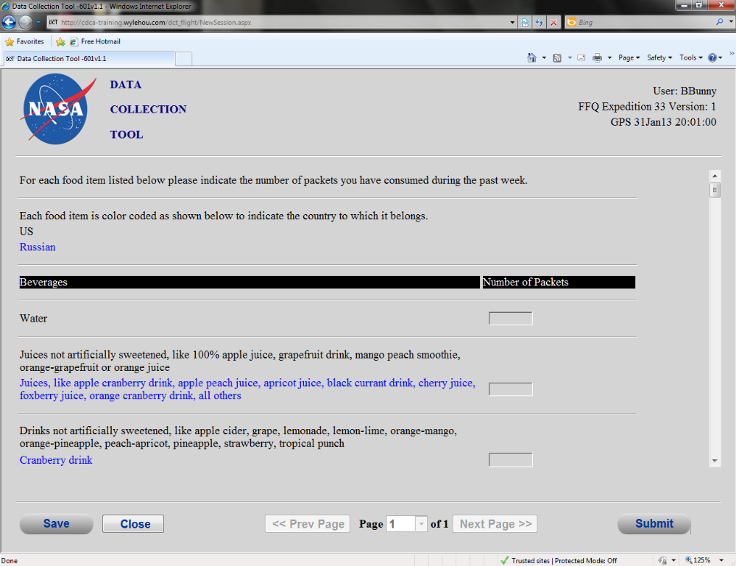

The food and beverage products are grouped in the list by the nutrient content. There are totally about 60 - 70 products in the list and several groups. Grouping of food/beverage products was fixed and is specially designed to calculate 7 main nutrient components (fluid, energy, protein, calcium, iron, sodium, potassium). The foods/beverages were placed to the groups according to their contained key nutrients.

The user scrolled the list of products and entered number of pieces that he/she consumed during the week. There were several pages on the list, so the user was able to quickly proceed through different groups of products.

Please note, food/beverage names were specially colored according to the supplier (black color – for US food, blue color – for Russian food). But that feature is not needed in the new version of the application due to bar codes scanning.

It was possible to enter several Additional Food Items (i.e. ad-hoc food products) at the end of the survey. The user could enter free form text name of the consumed food in the related text field and the consumed quantity. There was a special “Additional Comments” text area – it was used for entering any comments from the user to the survey. Please refer to the following screenshot for an example of those fields.

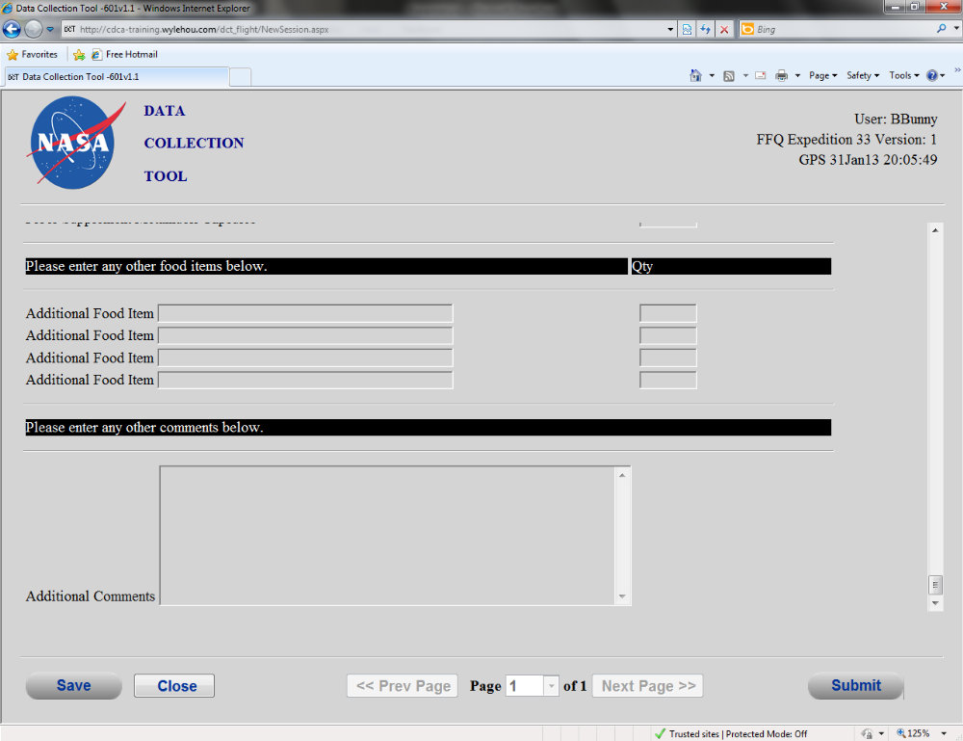

The FFQ process was based on weekly entering of the data by each astronaut. That weekly process took no more than 15 minutes per each astronaut. The user was able to save entered data and then submit it for sending to the Earth. The resulted survey data were quite precise for several astronauts, but data from other crew members were not useful for further analysis. The main reason was that the data were entered just once a week, so not all astronauts were able to exactly remember which food/beverage products they had consumed and at what quantity.

The submitted survey data were stored by FFQ tool to the dedicated folder on the shared file server located on the ISS. They were stored as files in the MS Excel format – please refer to the client-provided document in the “\client_docs\Generic FFQ Downlink.pdf” file. The file server has been automatically sending those files to the downlink. The files with tracked food intake surveys were delivered to the Earth laboratory for further offline processing. The Earth laboratory performed various analysis on those MS Excel files and determined amounts of key nutrition components consumed by each astronaut through the week. Then, that data was used to compare body, bones and muscle weight of astronauts, their work performance and other physical characteristics during the space mission on the ISS. Some useful feedback on the food diet was provided to the crew surgeon and the astronauts according to the performed research. Please note, that analysis and feedback reporting was performed outside the FFQ application.

Context Diagram
The Context Diagram illustrates the systems, modules, business processes, etc that feed or interact with this application, where the application is the “center of the universe.”

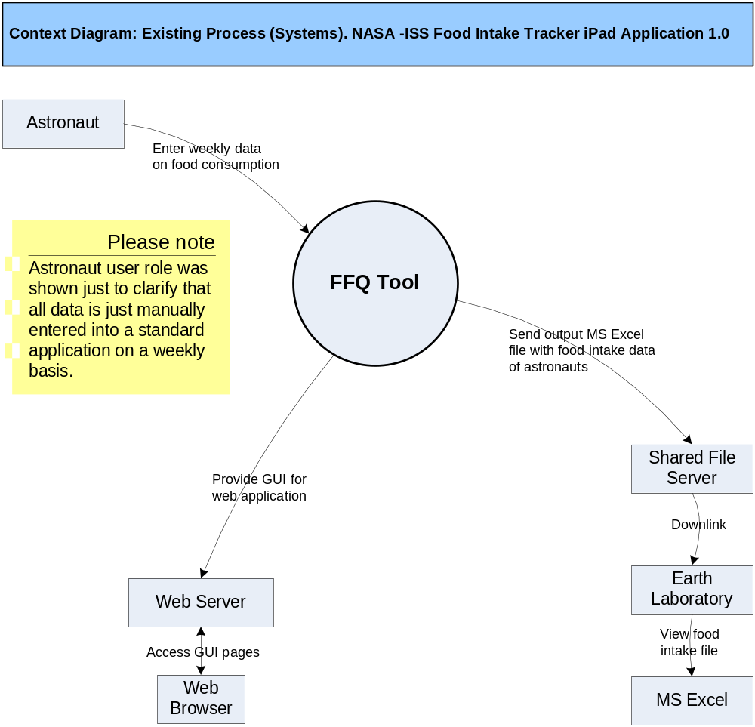

High Level Workflow
The workflow required to complete the primary objectives of this application is described below. The workflow is business-centered, and includes “decision forks” for decisions the business user, or application, must make to achieve the objective. The workflow omits application faults or exceptions. Individual tasks in the workflow are briefly described in section 2.3.2.

Workflow Diagram/Process Map
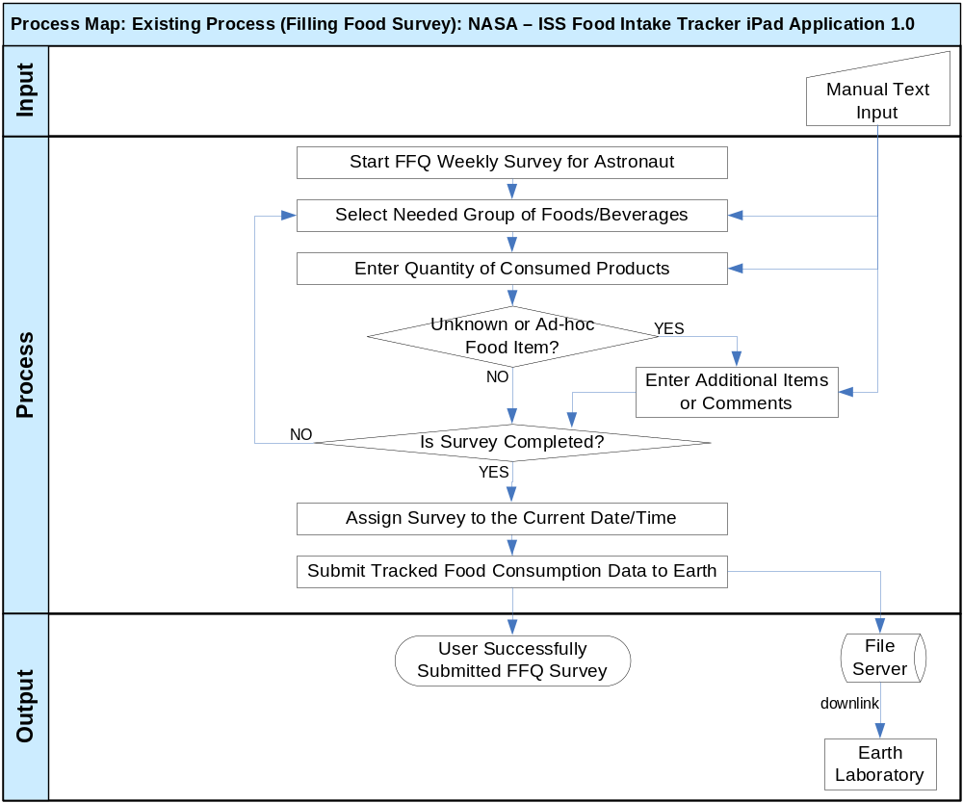

Workflow Description
Filling Food Survey:
- The astronaut opens the FFQ tool and starts his/her own weekly survey of food consumption.
- The user can select the group of food products from the list.
Possible opportunity: to quickly locate products by straightforward flat structure.
Possible problem: there was a problem that grouping was only by key nutrients, so it was not flexible.
  - The products are grouped by nutrient content, so the astronaut can quite efficiently locate the food/beverage items he/she consumed through the previous week.
- The user can enter quantity of the eaten food/beverage items.
Possible opportunity: to quickly enter summary amounts of weekly consumed food/beverage products, because there were only weekly fields, so the user wasn’t required to individually fill food intakes per each day.
Possible bottleneck: there can be a performance bottleneck if the list of existing food products becomes much larger (like 200 items instead of 60-70 items in the FFQ tool). In this case, scrolling through large lists and moving through the pages of the survey will be very time consuming so 15 minutes per week might be not enough for entering all the data. The issue becomes more serious, because remembering of the consumed food through the week becomes much more difficult in case of 200 products – it brings more delays to the survey.
  - The user will simply enter the summary quantity for each consumed product for the previous week (like 10 soups, 12 breads, 4 fried chickens, etc.).
  - The user simply enters the numeric value to the related field on the list.
- If the user ate some new/unknown food (that is absent on the survey), then it will be possible to fully manually enter data about that consumes product.
Possible opportunity: to allow simple abilities to enter flexible/custom data on food consumptions, so breaking limits of just listed foods/beverages on the survey.
Possible problem: there was a problem that several users could not remember exactly what and how much they had eaten through such a long period as a week. So, they entered imprecise, incomplete or incorrect data to the survey.
  - The user can enter free form (ad-hoc) text description of the consumed food/beverage product to the “Additional Food Item” field.
  - The user can enter the numeric value for quantity of the consumed ad-hoc food/beverage product.
  - It will be possible to provide any comments to the survey through the special text area in the FFQ tool (additional comments).
- The user can freely choose other groups of products on the survey, proceed to different pages of the survey and scroll the list up and down until – he/she will continue filling the survey until it is completed (proceed to the step 2 of the workflow). Else, the user finishes the survey (go to the step 6 below).
- The FFQ tool will allow assignment of the date/time of the survey completion.
Possible problem: there was a problem that no daily details on food consumption were tracked, but survey was performed strictly on the weekly basis.
  - The survey will be assigned to the previous week by default, but other dates range maybe also chosen.
- The astronaut submits his/her prepared survey on the food intakes and it will be saved to the shared file server.
Possible opportunity: to deliver weekly consumed food data to the Earth for further evaluation.
Possible problem: there was a problem that downlink delivery was performed not often – only on the weekly basis.
  - The FFQ tool will generate an MS Excel file with the entered food consumptions and save it to the special predefined folder on the shared file server for downlink.
  - The saved MS Excel file is automatically sent by the downlink to the Earth laboratory for further (offline) processing and analysis.

Dependencies
The list below enumerates external applications, business procedures, personnel, etc, that are required to achieve the objectives of the current application. For example, if the application is a data warehouse, it will depend on one or more OLTP systems at the enterprise. Those systems would be listed here.
- Astronaut
The crew members have been entering their food intakes into the standard computer-based application (FFQ) on a weekly basis. They entered data fully manually to several grouped lists of existing food products and were able to enter ad-hoc entries as well.
- Shared File Server
The FFQ application stored output MS Excel files with tracked food intake data of astronauts to the shared file server (for sending to the downlink).
- Earth Laboratory
The FFQ application delivered MS Excel files with tracked food intake data of astronauts to the Earth laboratory (through the shared file server). The Earth laboratory performed offline analysis on the received data.
- Web Server
The FFQ application provided its GUI through the web server.
- Web Browser
The users accessed the FFW application through the web-browser.
- MS Excel
The FFQ application generated an output file with food intake data in the MS Excel format, so the Earth laboratory had to have an MS Excel application for opening and processing that data.

Current Limitations/Problems
Limitations of and problems with the current application are listed below. These are the issues that the new application strives to address.
- The previously used FFQ was filled quite rarely (once per week), so many astronauts had forgotten exact types and quantity of consumed foods. Therefore, the tracked data was incomplete for some crew members and didn’t allow for proper analysis.
- It was very hard to use previous FFQ form, especially on the daily basis.
- The previous FFQ did not produce more nutrient information than just 7 key nutrient components (fluid, energy/calories, protein, calcium, iron, sodium, potassium).

Proposed Workflow

Overview
This section includes a concise description of the features and operation of the proposed solution. It also compares and contrasts the solution with the current process. The context and workflow of the proposed solution are defined in subsequent sections.

Comparison with an Old Approach
The previous FFQ application was not used frequently (just weekly) and it was very hard to use due to long lists to be scrolled and manually filled. User interface wasn’t convenient and it prevented daily usage of FFQ. As a result, some astronauts forgot which food they had consumed during a week, so they produced incomplete/inaccurate information to the survey.
- In contrast, the new mobile application will have an intuitive, simple, visually appealing and user friendly GUI, so it can be used on daily basis or even ad-hoc (right at meals).
- The new application can be easily used on iPad devices and allow to semi-automatically enter information about eaten food (like by scanning bar codes on food packets, recognizing food pictures, etc.).
- Researchers will receive complete, precise and even time stamped food consumption data from the new application.

The previous FFQ survey strictly grouped food/beverages by just several key nutrients and it was not intended to produce nutrient information above the main 7 nutrient components.
- In contrast, the new application will produce precise information about consumed food/beverage types and quantity, so powerful offline analysis can be performed on the Earth (out of scope for this mobile application).
- The new application will group food/beverage products in an intuitive way without restriction of just 7 nutrient groups, so the users will be able to very conveniently and quickly find proper food/beverage items in the application.
- The new application will have no restriction on adding more food/beverage products and groups of them, so there will be no such limitations on the further offline analysis.

New System Features
The new system will be a mobile iPad application allowing to easily track astronaut food intake data on the ISS. This highly interactive application will be for iOS-based tablet devices (iPads) and specially installed (not through the Internet) as a custom application to iPads currently located at the ISS facilities in the space.

The application will support various user roles, and their workflows are briefly described below.

Non Registered Users are simply new astronauts that start working with the application. They can just open the application, view help information on the application usage and then they are expected to register to the application. That common functionality of the application will be available for all the user roles. The registration process will be simple and intuitive. A very small amount of information will be asked by the application: first/last name. There will be additional registration options allowing to simplify user identification in the future:
- Ability to keep a picture of the user’s face to see on the login screen in the future.

The steps to register for an account will be:

- Click a "Register" button from the Home screen of the application.
- Enter their first and last name.
- Have the user take a photo of their face (for picture to display on the login screen)

The Registered User will be able easily login into his/her profile in the application. The login screen will show Photos of registered users, and the user will simply touch their photo to login (using the iPad touch screen). The selected user’s name and photo will be displayed and they can simply click a “login” button to login with the selected profile. There will be no username or credentials required.

It will be possible for users to freely update their own profile in the application – all data and options provided during registration process can be updated later by the user. Under the settings, the user will have the option to never be logged out automatically, or to automatically log out after 5 minutes of inactivity.

The Registered User can easily enter data about his/her food consumption to the application. There will be multiple possibilities to conveniently input food intake data into an iPad. They are so simple and fast, that it will be possible to efficiently perform that process weekly, daily, or even at meal time. It will take just like 10 – 20 seconds for saying the name of the food or scanning the bar codes on the food packet, so it can be performed even during eating, so elapsed time won’t be counted to the lost work time. For example, the astronaut can take an iPad to the dinner table – like many people do on the Earth (say for web-surfing). Then, he/she can just scan every food product being consumed, so the application will track food intake data with exact time stamps.

First, the user can just say the name and quantity of the being consumed food/drink product. The application will record the speech (say “Chicken”) and the amount of the food.

Second, the user can take pictures of the consumed food – the application will ask the user to enter the name of the food and optional comments for the food.

Third, there will be the most precise method – by scanning the bar codes on the food packet, but not all the foods on the ISS have bar codes. The quantity of consumed items can be entered manually (like described above), or by scanning the bar codes multiple times.

Fourth, the user just manually enters the textual name of the food (and quantity) on the touch screen. It will allow to select either existing food (like by auto-complete feature during text entering), or by ad-hoc entering of a new food (like an Additional Food Item in the previous FFQ survey). This approach can be useful for “unofficial” food that is specially packed and don’t have a bar code.

Fifth, there will be a special simplified ability to visually select the food or beverage from the well-structured groups of existing products. The user can either enter quantity or just press the same chosen picture multiple times. The proposed grouping idea is illustrated below. Please note, this is just a recommended idea, but actual graphical approach and design will be selected later – during Studio contests and are up-to the Studio designers.
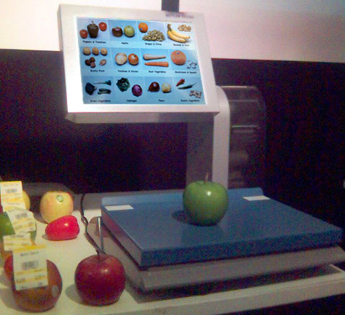

It will be very similar to how grouping of food product is performed on computerized touch-screen scales at regular supermarkets. There will be a flexible and easily customizable hierarchy of food/drink product groups. Each group will have a picture and a brief clear name (like fruits, soups, etc.). Multiple top level groups can be initially shown on the touch screen on several tiles (like 9, 12, 16, etc.). If count of top level groups is larger than the single screen space, then there will be several pages, so the user can swipe pages on the screen of the iPad by the related finger touch gesture. Please refer the picture on the next page for the example graphical representation. Those images are from the following web-site (with Creative Commons License):
https://www.evernote.com/shard/s16/sh/7d993a26-0ded-47cc-b775-f9000ad70b71/85da2e03e2419134085e6a51897bb4a3
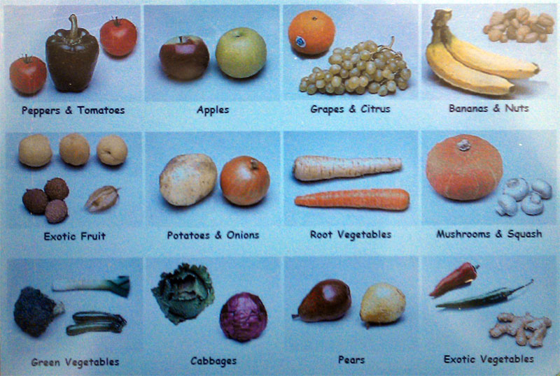

After selecting the high level group (say “Soups”), the user will be presented by the nested more detailed groups (like “Vegetarian Soups”, “Meat Soups”, “Fish Soups”, etc.). Or there could be no nested groups, but just pictures and names of the related foods/beverages. Food products will be shown in the similar way as groups (i.e. with the visually attractive and clearly identifiable picture, name, and maybe a code number). There can be also multiple pages of food products on the screen, so the user will swipe pages to find the needed product. Additionally, products and groups can be sorted alphabetically (or by popularity, or by concrete user preferences, etc.) for user convenience.

This proposed food products grouping and selection have been proven at supermarkets. It is very intuitive, easy to use, visually attractive, and very efficient – there will be needed just a few finger touch gestures on the screen to precisely locate the consumed food/drink product.

In the Food Product Area, there will be a small alphabet going down the right side of the screen so a user wouldn’t have to scroll all the way to the bottom to get to a product that starts with a Z. They could tap the z area on the alphabet and get there much faster.

Please note, each selected consumed food/beverage product will be tracked with a timestamp – either the current date/time, or chosen/entered by the user.

The user will be able to enter free form comments to his/her food consumption data. It can be performed either manually (by virtual touch screen keyboard), or by voice recording of the user’s speech.

The user will also have the option to copy a food/meal from one day to the next. To do so, the user will select either an individual food item or an entire meal they have previously entered to copy to the current day. The time consumed, quantity, and food item should all be copied when the user performs this function.

Users will also have the ability to view a list of their favorite foods (ones that have been entered on previous days). The system will automatically generate a list of food items the user has recently consumed. The user can also select filters to view a list of yesterday’s food consumed, this week’s food consumed, or this month’s food consumed and the system will populate the list based on this filter. Once the favorite list is displayed, the user will have the option to select foods from the list to add to their consumption for the current day.

If a crewmember enters a food that is not in the database, the application will have the ability to uplink nutrient content to the program and have that person’s file auto-update with the added nutrient info. The food categories in the application will have the ability to be modified by the uplink (from the ground lab).

The user can view and modify his/her previously entered information about consumer food/beverages (i.e. change it to another food product, change quantity, change timestamp, remove entirely). The stored food consumption data will be displayed on the visually appealing calendar, or on the detailed list, or on the summary list – up-to the Studio designer.

The registered user will be able to freely manage (view, add, edit, remove) food/beverages products existing in the application. It will be possible to perform those actions in the similar way as it has been already described above – i.e. through inputting information by voice recording, by taking pictures of the products, scanning bar codes, selecting products/groups on touch screen, or fully manually entering text data. The hierarchy of the nested groups of foods/beverages will be also managed in this way.

The registered user can configure his/her preferences in the application – like preferable options for login/identification, the preferred method of entering consumed food data, most preferred products, etc. It will be performed on visually attractive and easy to use GUI pages.

The registered user can freely view and update his/her own user profile on visually appealing GUI screen (like performed during a registration process).

There can be some Administrators in the system. The Administrator user role can be assigned to registered users by other existing administrators or by a special command from the control file received by uplink. The Administrator will be able to perform all actions of regular registered users and the Administrator can additionally access (view, edit, remove, create) all the data (including food intakes) of all the users in the system.

The Administrator can manage (view, edit, remove) create profiles of all the users in the system and modify user roles. Just standard text input on touch screen is enough for such management.

The System actor represents the background and low level features in the application. The system will automatically share application data between multiple iPads. There will be multiple iPads that are not personally assigned, so the user will be able to use any of them to login and enter some data (say breakfast food consumption), then use another iPad to enter more data (say his/her lunch food consumption). The application will automatically implement combined data delivery through Wi-Fi network, so all iPads will have complete up-to-date data.

There will be a special shared file server, so the application will persist data on it. The server will be mostly used for storing output MS Excel files with food consumption data for the downlink, and for input control files from the uplink.

The system will automatically generate output tracking file (in MS Excel format) with collected food/beverages intakes for astronauts. The output file will be sent to the downlink through a special folder on a shared file server.

The system will receive control data files from the uplink through a special folder on a shared file server. That file will have control data, configuration and special commands for the application. The system will process commands from the file and apply them to the application accordingly (like to add/update/remove existing food/beverages data, add/update/remove user profiles, assign/un-assign Administrator user roles, update application configuration, etc.).

The system will automatically and promptly remove processed output/input files from the shared file server due to disk space limitations.

The system will implement and support various data recognition algorithms for bar codes. The algorithms will be smart and efficient (up-to the Architect). They will be performed right on iPad devices on the ISS, so there will be NO need to send large amounts of raw data for significantly delayed offline processing to Earth.

The system will need to calculate some basic nutrition content to display to the user on the summary page. The calculation will be based on the limited nutrient content information available (NOTE: full nutritional analysis is still out of scope and will be done externally for this iPad app.)

The calculated basic nutrition content will be displayed to the user on the Summary page, next to food name. The system will display calories and sodium content of the item, and either at the bottom of that screen, or on another screen after pressing a button at the bottom of the screen to calculate nutrition, to display daily total calories, sodium, and fluid consumption. Below the calculated values there must be a note that explains that these are preliminary calculations only, and may not include all food items (e.g. official results pending detailed report analysis).

All the occurred errors, exceptions, warnings and debug information will be automatically logged by the system on the iPad devices (configurable).

Context Diagram
The Context Diagram illustrates the modules, business processes, etc that feed or interact with this proposed application.

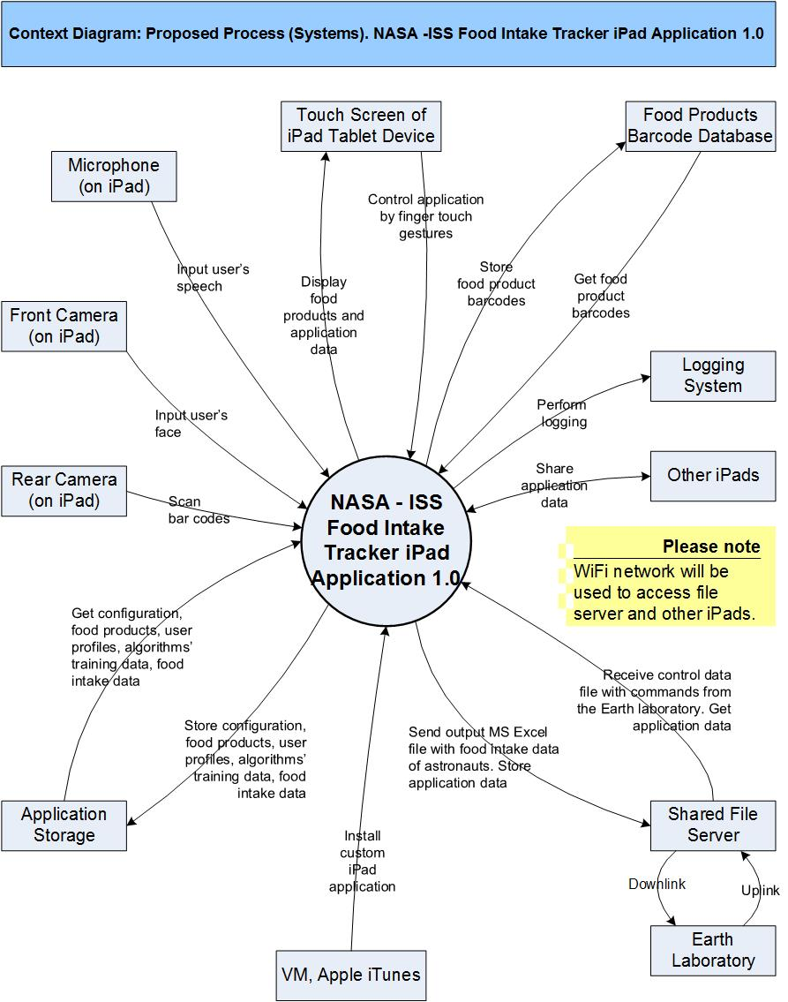

High Level Workflow
The workflow required to complete the primary objectives of the proposed application is described below. The workflow is business-centered, and includes “decision forks” for decisions the business user, or application, must make to achieve the objective. The workflow omits application faults or exceptions. Individual tasks in the workflow are described.

Workflow/Process Map Diagram
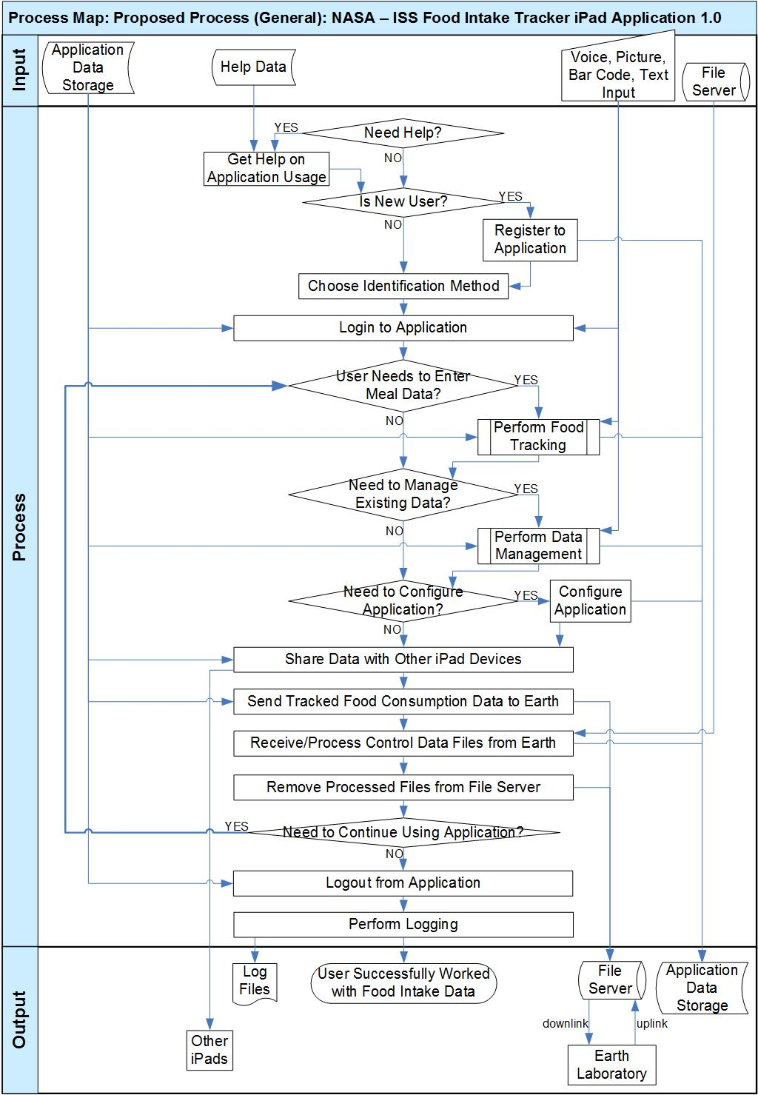
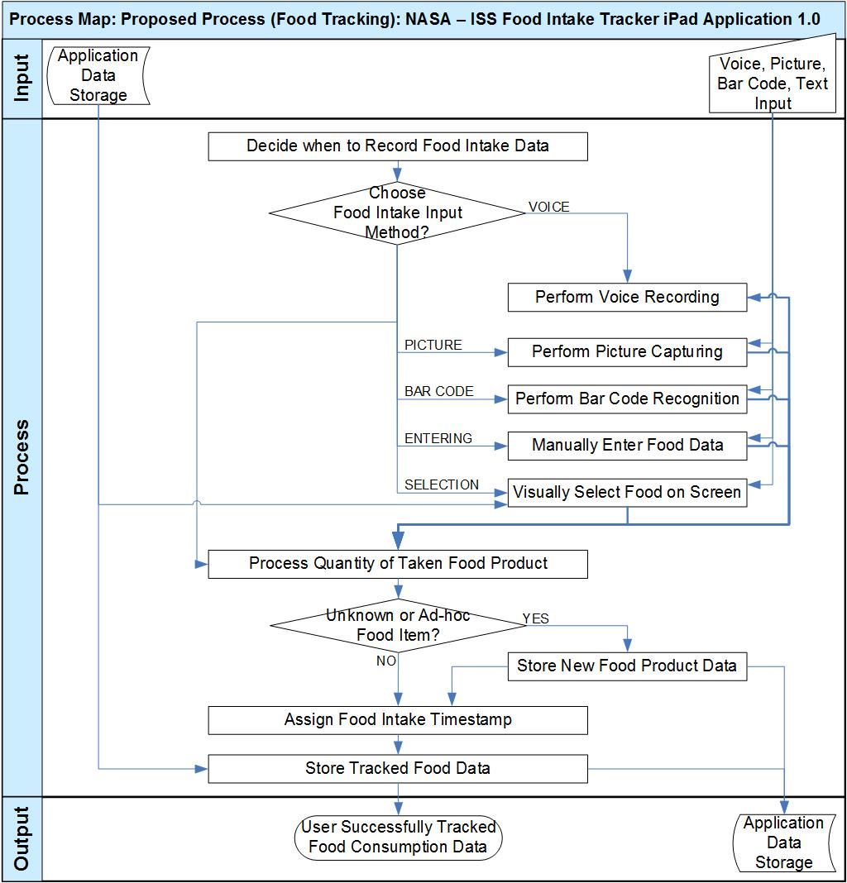

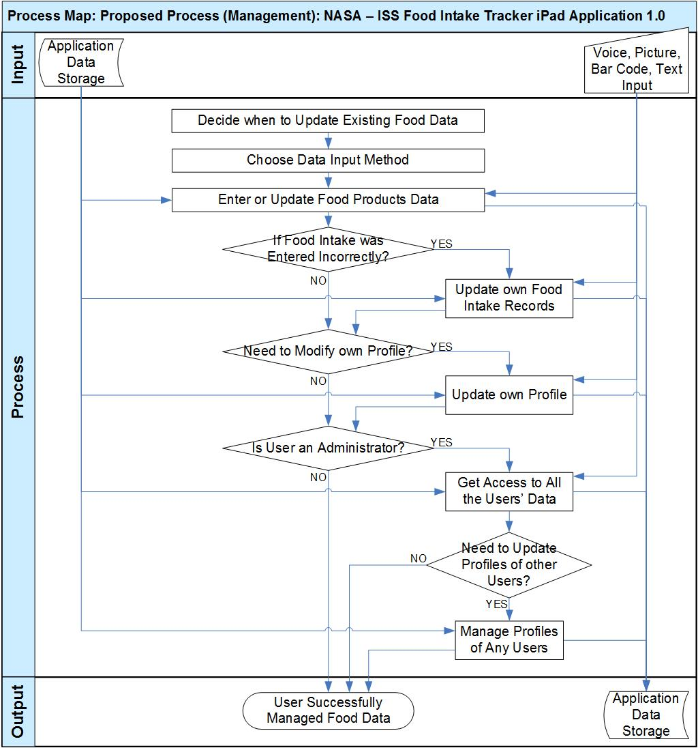

Workflow Description
General:
Please note, there are no expected bottlenecks in this workflow, because the count of users will be very small, quantity of iPads is enough, amount of stored data is very small, processing performance of iPads is appropriate for bar codes recognition algorithms, and the size of generated MS Excel files is very small.
- The user can easily learn how to use the application, because it will have an intuitive and user-friendly interface, and some help content on the application usage will be provided as well.
  - Quick access to help information will be always possible to the user – like through a special button “Help / Settings”.
Possible opportunity: to efficiently inform user how to use the application, so the user will quickly get convenient with the application interface.
- If the user is new (i.e. just installed and opened the application), then the application will ask him/her to register to the application and provide identification data for accessing more features of the application (i.e. as a registered user).
  - The application will ask the user to provide just a very small amount of information - only first/last name.
  - The user can take a photo of his/her face in the application (by an iPad camera) to see on the login screen.
  - The account of a new user will be created in the application and stored to the iPad device.
  - The user will be assigned to the “Registered User” role.
- The user can login to the application by touching his/her photo on the login screen.
  - The user is allowed to login to the application by tapping their photo on the login screen.
  - The login screen will show Photos of registered users, and the user will simply touch their photo to login (using the iPad touch screen).
  - The selected user’s name and photo will be displayed and they can simply click a “login” button to login with the selected profile.
  - There will NOT be any username or credentials required to login.
- The standard usage of the application will be performed in the loop. If the user needs to enter information about his/her food consumption, then he/she can easily do it on any preferred schedule (like weekly, daily, right at meals, etc.).
  - Please refer to “Food Tracking” workflow below for more details on how the user input food/beverages intake data into the iPad application.
- If the user needs to update the existing food products or enter new food/beverage information, then it will be always possible in the easy and visually appealing way.
  - Please refer to “Management” workflow below for more details on how users manage data in the application.
- If the user wants to adjust application behavior according to his/her needs, then it can be performed through configuration.
Possible opportunity: to allow easy customization of the application.
  - The application will support easy configuration on the visually appealing GUI screens.
  - Values of configuration options will be individually persisted for the concrete users.
  - Configuration options will contain identification/login preferences, the preferred method of entering consumed food data, most preferred products, etc.
- The application will automatically share entered/updated/removed data through all the dedicated iPads on the ISS.
Possible opportunity: to allow simplified usage of non personalized iPads.
Possible problem: there can be a problem that Wi-Fi network coverage is incomplete on the ISS, so it can delay communications between iPads.
  - There are multiple iPads on the ISS and those devices are shared by all the astronauts, so the application will automatically combine all the data entered/modified from all the iPads and deliver that combined data through all the dedicated iPads.
  - As a result, the users can work with any of the dedicated iPads and always get up-to-date information on the existing foods/beverages and their food intakes.
- The application will automatically send the entered information of the consumed food/beverages to the Earth.
Possible opportunity: to seamlessly deliver precise data of consumed foods/beverages to the Earth laboratory for further offline research. The delivered data won’t be very large due to no need to send pictures and voice data to the Earth.
Possible problem: there can be a problem that Wi-Fi network coverage is incomplete on the ISS, so it can delay sending data from iPads to the shared file server.
  - The application will generate an MS Excel file with information about food intakes of astronauts and store that file to the configured downlink folder on the shared file server (present on the ISS).
  - The shared file server will detect new output files from the application and automatically deliver them to downlink, so files will be send to the Earth laboratory.
- The application will automatically receive and process control data files from the Earth.
Possible opportunity: to support efficient and easy management of the application from the Earth laboratory.
Possible problem: there can be a problem that the received data is corrupted and wrong information is received, so the data format of the file should be reliable to determine if the file was transmitted correctly.
Possible problem: there can be a problem that Wi-Fi network coverage is incomplete on the ISS, so it can delay receiving data from the shared file server.
  - The application will scan a special configured uplink folder on the shared file server for the new incoming files.
  - The incoming files from the Earth laboratory are automatically delivered to that uplink folder on the shared file server on a regular basis.
  - The application will parse the received file and perform commands accordingly.
  - The application will add/update/remove existing food/beverages data, add/update/remove user profiles, assign/un-assign Administrator user roles, update application configuration according to the information received from the Earth in those control files.
- The application will automatically delete all the already processed files from the shared file server.
Possible opportunity: to efficiently use highly limited disk space of the shared file server.
  - The disk space of the shared file server is a very important resource on the ISS, so the application should immediately remove own input/output files that are no more needed.
- The user can continue working with the application and proceed to the step 4 of the workflow, or decide to logout and exit from the application (proceed to the step 12).
- The user can perform logout from the application to ensure high security – this application provides quite sensitive data to him/her, so the user has to logout as soon as he/she does not need to access the application any longer. If the user stays always logged in, then sometime he/she can leave his/her mobile device alone and somebody can access the application instead of the user.
- The system will automatically log all the errors, exceptions, debug and warning information during the mobile application execution. Logging will be performed to some sort of the logging system and the information can be stored to log files on the mobile device. Please note, the logging step was show just once on the workflow for clarity, but that step can be actually performed at any place of the workflow according to the application needs.

Food Tracking:
Please note, there are no expected bottlenecks in this workflow, because the count of users will be very small, quantity of iPads is enough, amount of stored data is very small, processing performance of iPads is appropriate for bar codes recognition algorithms, and the size of generated MS Excel files is very small.
- The new application will be user-friendly and easy to use, so the user can use it very frequently for entering food consumption data without any significant losses of work-time.
  - The user can enter data of the consumed foods/beverages on a weekly basis – i.e. he/she will try to remember all the food intake through the week and then input all the items on one-by-one item. The user will just visually choose the proper day of week from the on-screen calendar, then the proper food product.
Possible opportunity: to support batch entering of food products consumed for the entire week.
Possible problem: there can be a problem that the user can forget what was actually consumed during such a lot interval as a week, so he/she enters imprecise data.
  - The user will have no problems to decide entering consumed data on the daily basis (like at night). It will be very easy to fill breakfast, lunch, dinner and ad-hoc parts of daily consumption.
Possible opportunity: to support fast and intuitive entering of small sets of food consumed data.
  - It will be especially convenient if the user decides to input food intake data soon after the meal, or maybe even just right at the meal. In this case he/she can scan/input being eaten product by one hand and use another hand to hold the food product during eating. It means that no work time will be lost in this case.
Possible opportunity: to save working time by very convenient entering a few consumed products right at the meals.
- The user can select various input methods to enter information about consumed food and beverages.
Possible opportunity: to enter data of the consumed food in an intuitive, user-friendly, and very quick manner.
  - The user can just say the name of the consumed food product to the iPad microphone, so the application will record his/her speech then the application will save the speech.
  - The user can snap a photo of the being consumed food product by iPad rear camera, so the application will save the photo. The user can be asked to enter the food name, comment (optionally) to store the food product.
  - The user can point the rear camera of iPad to the bar codes on the food/beverage for very precise and fast recognition and matching of the product against the existing foods/beverages.
  - It will be possible to just manually enter the text name of the food on the touch screen.
  - The user can easily select the consumed food product through the groups of foods/beverages on the screen. There will be a special visually appealing GUI like on the supermarket touch-screen scales, so the user will be able to very quickly and efficiently locate the needed food/beverage product.
  - There is a convenient way to add drinking water quickly – there will be a button to add 1 pkg of drinking water immediately. By default the packet is 1, the user can increase/decrease the amount as usual.
- The application will allow the user to easily input quantity of the consumed food products.
  - By default, it will be just value 1 packet for each chosen/entered food/beverage product. It will be enough in most cases.
  - The user can increase quantity just by repeating entering that food product (like re-scan the bar code, etc.).
  - The user will be able to easily increase/decrease quantity on the touch-screen.
  - It will be possible to manually enter an exact count of the consumed food product (including fractional – for shared food with other astronauts).
- Please note, every food intake input method (described above) support entering data of the unknown, unofficial, or ad-hoc food. If the inputted data of consumed product doesn’t match the currently stored list of existing foods/beverages, then the application will allow the user to add a new food product to the system.
Possible opportunity: to support ad-hoc input of consumed food products that were absent in the list of the existing products.
  - The application will accept data entered by the user and add that data to the system.
  - That food will be automatically assigned to the “Ad-hoc” group of foods/beverages, but the user can choose any of the other existing groups (or create a new group) for that newly entered product.
  - The user will be able to enter free form comments to his/her food consumption data. It can be performed manually (by virtual touch screen keyboard).
- The application will automatically assign the timestamp to the tracked food product and allow the user to manually change date/time.
Possible opportunity: to get precise information about when the food products were actually consumed by the astronauts.
Possible problem: there can be a problem that the time zones on the ISS are constantly changed and does not relate to the time zone at the Earth laboratory.
  - By default, the application will assign current GMT date/time stamp when inputting data of the food intake, because the application is mostly intended for ad-hoc usage – like just after or at the meals.
  - The user will be able to easily choose another date or time. It will be performed in a visually appealing way – like by choosing the day from the on-screen calendar, by selecting time by a single tough gesture from the timetable on the screen, etc.
  - The application will support the batch entering of food consumption at the end of the week, so the user will be presented with the calendar, groups of meals (breakfast, lunch, dinner, ad-hoc) and graphical timetables – it will be like a dashboard or a checklist to fill in. So the user can very precisely and quickly fill that weekly dashboard/checklist in – either in consecutive or fully random manner of selecting days/times.
- The application will automatically store complete tracked food data.
Possible opportunity: to reliably keep all the entered data on food intakes for further delivery to the Earth and for accessing by the related astronaut.
  - The user’s consumed food/beverage data will be stored, so the user can later access that data. The data will be initially stored to the iPad devices, because there are disk space limitations on the shared file server and that server can be not available at the moment. But there should NOT be abilities to just copy-paste old data to the new days or weeks.
  - Please note, that information will be automatically shared to other dedicated iPads on the ISS, so the user can work with that data from any related iPad on the ISS.

Management:
Please note, there are no expected bottlenecks in this workflow, because the count of users will be very small, quantity of iPads is enough, amount of stored data is very small, and processing performance of iPads is appropriate for bar codes recognition algorithms.
- The user can decide to update existing food data at any moment during the application usage (for example, it can be a special predefined button on the screen – up-to the Studio designer).
- The user can choose the needed data input method (voice, picture, bar code, manual entering/selection) – like described above (in “Food Tracking” workflow).
- The user can enter or update the information about existing food product.
Possible opportunity: to support easy and intuitive adding/modification of the food products to the system.
  - Adding of a new food/beverage product will be similar to inputting consumed foods/beverages – like described above (in “Food Tracking” workflow). The application will simply determine that the entered product is absent in the list of the existing stored foods/beverages and allow the user to add and store that item to the system.
  - Updating of the existing food/beverage product will be very similar – the user should just select the existing product in the application, ask the application to edit it, and then either scan/recognize the product again or manually change the existing text data of the product.
  - The user can freely modify grouping of products in the application. He/she can add/update/remove groups, assign/un-assign products to the groups, modify groups nesting.
- If the user found that he/she has incorrectly entered some data of his/her consumed food, then the user can easily fix this issue.
Possible opportunity: to allow correction of user mistakes on the food intakes, so the final data will be very accurate.
  - The user will be able to view and modify own food intake records, though editing of tracked food data will be limited to a few days (configurable).
  - Data modification can be performed with any of the available input methods (voice, bar code, etc.) or by manual editing on the visually appealing touch screens.
  - The modified data will be stored to the application and can be even transmitted again to the Earth if wrong food consumption data has been already sent to downlink.
- If the user needs to change something on his/her own profile (account) then the application will allow to do that.
  - The user can view and edit all the data fields on his/her own profile at any moment.
  - The user can change identification methods and modify his/her face photo.
- If the user is an Administrator, then the application will provide additional management features.
  - The Administrator can view all the data of all the users. It means there will be a list of users, so the Administrator can choose the needed user and then view all the food intake information of the user (like on the calendar, or on the list with detailed and summary information).
Possible opportunity: to support manager’s access to the data of all the users in the system.
  - If the Administrator needs to manage users in the system, then he/she can perform this on visually appealing touch screens.
Possible opportunity: to easily control all the user profiles and their user roles in the system.
    - The application will display list of users (pictures of users are suggested for displaying).
    - The Administrator can open a profile of any user and update it in the same way as the regular user manages his/her own account.
    - Additionally, the Administrator can freely add new user accounts to the system and remove existing user accounts (and entire data of that account – it can be useful after the end of space mission for the related astronaut).
    - The Administrator can also assign Administrator user role to (or un-assign it from) the other user account.

Use Case Diagrams
Use case diagrams are helpful illustrations of how the application’s users interact with the system. Use case “bubbles” correlate to distinct task domains and are useful in determining user roles, module boundaries, shared tasks, etc. The use case diagram are intentionally high level, and exclude activity details such as for example “submit shopping cart.” The diagram below should be used to verify that the required functionality of the application is covered.

The use case diagrams use the next coloring schema for bubbles:
Color | Description
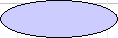 | The regular (concrete) use case
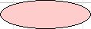 | The aggregate use case
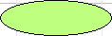 | The external use case (not in scope)

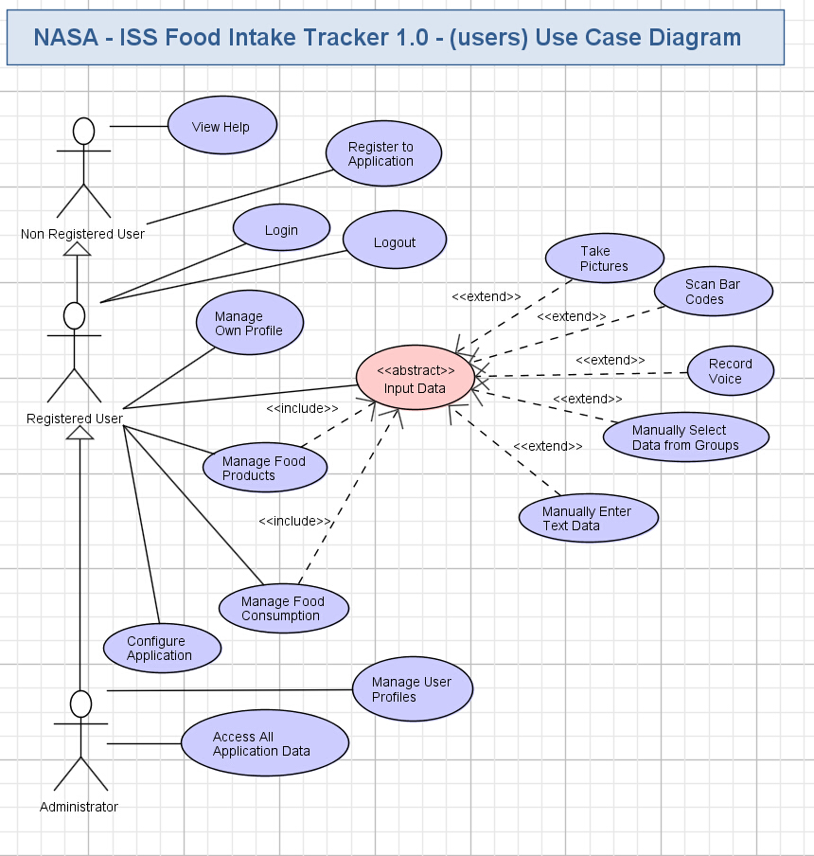
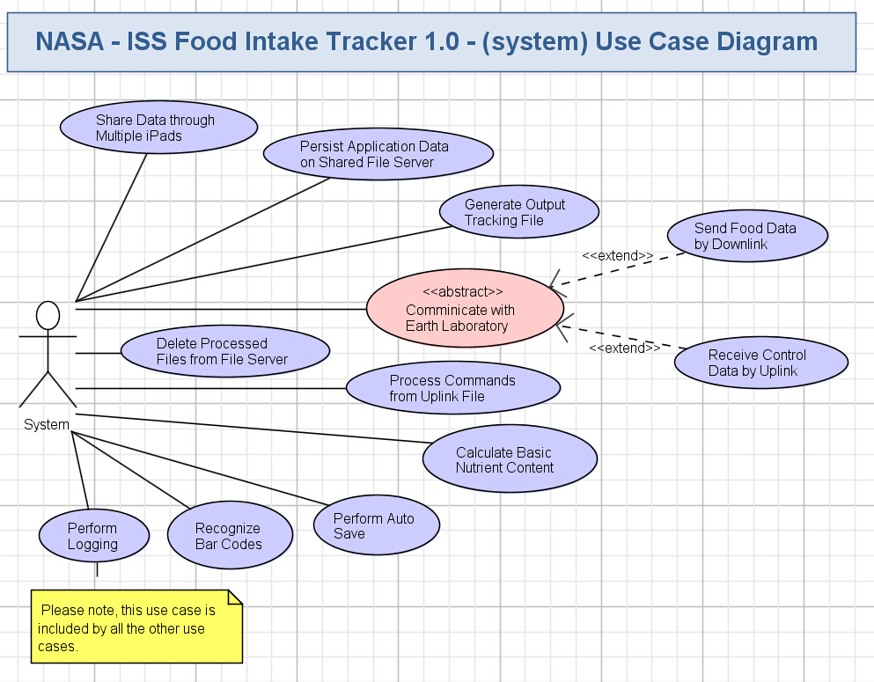

Business Requirements

This section identifies, enumerates and explores the business requirements that must be met by the application. Business requirements include capturing the types of users, the basic inputs and outputs, the system’s dependencies, and the tasks the system should accomplish. Some business requirement for a web-based retail site might include:

Users: “The system supports public browsers, registered members, customer service administrators, and system administrators.”
Tasks: “Users have personalized accounts,” “shopping carts expire in a configurable period, and the default is 10 days”, etc.

It is important to confirm that Task Requirements include all the tasks required to meet the business objectives.

Users
All applications have users and most have several users of different types. This section identifies, at a high level, the types of users of the system.

Non Registered User
This is a user who did not register to the application. He/she can just get help on the application usage, and register to the application to get more features.

Registered User
This user role describes features allowed for the users after they register to the application. The registered user can perform all actions of the non-registered user, can login to the application with various identification features, can provide food consumption data, manage existing food products, configure application and manage own profile.

Administrator
This is a management user role. The Administrator can access all data in the application and manage all the user profiles in addition to performing all actions of the Registered User role.

A System actor was added to the use case diagram to specially highlight that logging, sharing data through iPads, working with file server, generating output MS Excel file with food intake data, sending/receiving data to/from the Earth, processing commands from the Earth, recognizing various types of data (voice, bar codes) are automatically performed by the application on the iPad device (like in background).

Inputs/Outputs
This section identifies and describes the inputs to and outputs from the new application. Inputs can include electronic inputs, like RSS and EDI feeds, updates from external databases, etc, as well as human inputs, like “user X keys in results from report Y.” Output can include electronic feeds, printed reports, etc. In this section, all electronic inputs and outputs are captured. Human inputs are omitted from this section.

Inputs

Food/Beverage Product Data
The user will be able to input and manage the information about available food/beverage products into the application. This data will be used for simplifying inputting of food consumptions.

Food Consumption Data
The user can input information about his/her food intakes into the application. That’s a main purpose of this application – to collect actual food diet data from astronauts.

User Comments on Food Consumption Record
The user will be able to enter free form comments to his/her food consumption data. It can be performed either manually (by virtual touch screen keyboard), or by voice recording of the user’s speech.

Control Files from the Earth
The application will receive control files with user profiles, configuration, and foods/beverages data from the Earth (through uplink). The files will be retrieved from the shared file server.

Login Credentials
The user can enter his/her credentials (username) to login to the application. There will be other user identification methods too.

Face Images
The user can take a photo of his/her face for simplified login by tapping their photo on the login screen.

Voice Data/Commands
The user can input text data and perform recording by speaking into the iPad’s microphone. This input method can be used for entering food intake and managing existing food/beverage products data.

Pictures of Products
The user can take pictures of the food/beverage products with the iPad’s camera to store that data in the application.

Pictures of Bar Codes
The user can scan images of bar codes on the food/beverage products by the iPad’s camera. Bar codes recognition algorithm can use this input method for entering food intake data.

Configuration Data
The user can configure general options of the application (like preferable options for login/identification, the preferred method of entering consumed food data, most preferred products, etc.).

User Accounts Management
The user can register his/her account on the application. He/she can freely edit his/her account. The Administrators can freely view/create/edit/remove accounts of all the other users.

User Access Rights Management
The existing administrator can assign an Administrator user role or remove that role for any registered user in the system.

Finger Touch Gestures
The application will be controlled mostly through touch screen by using finger touch gestures (single and multi-touch ones).

Shared Data from other iPads
The application will receive shared data from other iPads – all the inputted food intakes, information about available foods/beverages, user profiles, configuration, etc. information. Actually, all the data entered by the user on a given iPad will be delivered to all the other dedicated iPads on the ISS.

Temporarily Persisted Data from Shared File Server
The application can receive some temporarily persisted data from the shared file server. It can be some newly entered information that couldn’t be delivered to all iPads due to incomplete coverage of the Wi-Fi network on the ISS.

Outputs

MS Excel File with Food Intake Data
The application generates MS Excel file with tracked food intake data (and comments) from astronauts. The file is stored to the special predefined folder of the shared file server.

Help Information
The application will provide help information on its usage (help pages, guides, getting started, etc.) to the user.

Displaying of Stored Data for Food/Beverage Products
The application will conveniently display data of the existing foods/beverages. There will be a special visually appealing grouping of food/beverage products on the screen.

Displaying Tracked Food Consumption
The application will allow the user to conveniently view his/her tracked food/beverage intakes. It will be displayed on the convenient calendar, or on the detailed list, or on the summary list.

Displaying User Profiles
The application will display the own profile for each user. The application will display lists of all the users and their profiles to the Administrator.

Data for Sharing on other iPads
The application will share all the entered data to all the other dedicated iPads on the ISS. Data sharing can be performed directly between iPads, or with the intermediate help of shared file server (when some iPads are outside the Wi-Fi coverage or turned off).

Data for Temporal Persisting on Shared File Server
The application will store some newly changed/add data to the shared file server. It can be used to deliver all up-to-date data to all the iPads on the ISS when some iPads are either turned off or are not in the Wi-Fi network).

Logging Data
The system will perform logging of all the errors, exception, debug, warning information during the mobile application execution to the logging system (like to log files).

Individual Configuration
The application stores its configuration data individually – per each user.

Removal of Processed Files from Shared File Server
The application will automatically remove its used files from the shared file server after finishing processing of them. This is a special communication request to be sent from the application to the shared file system. This feature will keep enough space on the file server’s disk, because that resource is very limited on the ISS.

Dependencies
Human inputs are also categorized as dependencies. List all dependencies.

Touch Screen of iPad Tablet Device
The application interface will be specially designed to work on iPad tablet mobile devices. The mobile application will display food data and other information on touch screens of iPad tablets, so the user will be able to easily and intuitively access and control information through touch finger gestures.

Microphone (on iPad)
The application will use iPad’s microphone to input user speech (for voice recording).

Front Camera (on iPad)
The application will use iPad’s front camera to acquire images of the user’s face.

Rear Camera (on iPad)
The application will use iPad’s rear camera to acquire pictures, scan bar codes (for bar codes recognition algorithms).

Application Storage
The application will store configuration, food products, user profiles, algorithms’ training data, food intake data to the application storage (like files).

VM
The VM image will be used for distribution of the application and custom install on the iPads located on the ISS.

Apple iTunes
Apple iTunes will be used for preparing the application distribution and for custom installation on iPads that are present on the ISS.

Logging System
The application will log all the errors/exceptions/debug/warnings information to some logging system. For example, file based logging can be implemented.

Other iPads
The iPad application will automatically share the entered data to all the other dedicated iPads on the ISS.

Shared File Server
The application will store output MS Excel files with tracked food intake data of astronauts to the shared file server (for sending to the downlink). The application will retrieve control files from the shared server (received from the uplink). The application can temporary persist its data to the shared file server for usage through all the iPads.

Earth Laboratory
The application will deliver MS Excel files with tracked food intake data of astronauts to the Earth laboratory (through the shared file server). The Earth laboratory will perform offline analysis on the received data (out of scope for this application). The application can also receive control files with food products data and user profiles from the Earth laboratory (through the shared file server).

Food Products Barcode Database
The application will store barcodes of the available food/beverage products to a special storage – it can be either a database, or some set of flat files, etc. local storage on the iPad device.

Human Dependencies

Non Registered User
Please refer chapter 4.1 for details.

Registered User
Please refer chapter 4.1 for details.

Administrator
Please refer chapter 4.1 for details.

Task Requirements
Task Requirements correlate to the use cases, above. There should be at least one task for each use case bubble. Each use case should be briefly described. If there are specific requirements related to the use case, they should also be listed. This section captures high-level, basic functional requirements. Detailed requirements will be defined during the Requirements Specification contests.

Non Registered User Functionality

View Help
- The user can easily learn how to use the application, because it will have an intuitive and user-friendly interface, and some help content on the application usage will be provided as well.
- Quick access to help information will be always possible to the user – like through a special button “Help / Settings” on the start screen of the app.
- Guidelines on the application usage will be available like simple help pages or a document.

Register to Application
- The non-registered user will freely register to the application through a simple intuitive process.
- A very small amount of information will be asked by the application: first/last name.
- The steps to register for an account will be:
  - Step 1: Click the "Register" button from the Login page.
  - Step 2: Enter first name and last name (the name which the user will see on the login screen)
  - Step 3: Have the user take a photo of their face (the photo the user will tap on the login screen)
- There will be additional registration options allowing to simplify user identification later (when performing login):
  - The user will be able to take a photo of his/her face in the application (by an iPad camera).
  - When taking a photo for photo login, we should have an option to take the photo. The system can do it automatically, but that may be problematic because users will be moving slightly in microgravity, so if they can press a "Take Photo" button in addition to it working automatically, that would be best.
  - After the photo has been taken, there should be "Cancel", "Retake Photo" and "Finish" buttons.
- The account of a new user will be created in the application and stored to the iPad device.
- The user will be assigned to the “Registered User” role.

Registered User Functionality

Login
- If the user has selected the option to never be automatically logged out of the application (via settings) and has not manually logged out, then he/she will be automatically logged in when starting the application next times.
- Else the application will show standard login screen and ask the user to login (various identification options exist):
  - The user is allowed to login to the application by tapping their photo on the login screen.
  - The login screen will show Photos of registered users, and the user will simply touch their photo to login (using the iPad touch screen).
  - The selected user’s name and photo will be displayed and they can simply click a “login” button to login with the selected profile.
  - There will be NOT be any username or credentials required to login.
- The bottom of the login screen will need to include an area to display some text/directions to provide for the user.
- After the user logs in the main screen / summary page will be displayed.
  - The calculated basic nutrition content will be displayed to the user on the Summary page, next to food name.
    - The system will display calories and sodium content of the item, and either at the bottom of that screen, or on another screen after pressing a button at the bottom of the screen to calculate nutrition, to display daily total calories, sodium, and fluid consumption.
  - The total daily calories, sodium, and fluid scales displayed on the bottom of the summary page will automatically be color coded to red, yellow, or green based on how close the amount is to the daily total for the user. For calories and fluid the coloring should go from red (too little intake) to green (intake closer to 100% of requirement, which is 2000 mL/d for fluid). For sodium, less intake is better (green). Above 3500 mg/d should be yellow, above 4500 should be red. These limits should be adjustable in the future, for each crewmember, and if defined requirements change.
  - The summary page will include the user’s name at the top to make sure the correct profile is currently selected.

Logout
- The logged in user will be able to logout from the application at any time. This feature will be used to improve security when the user has no more needs to use the application.
- The logged out user will lose access to his/her previously available functionality in the application – he/she will get just read-only functionality from the application (like a non registered user).
- There will be an automatic logout when the user closes the application on the mobile device.
- There will be an automatic logout if the user doesn’t use the application for a long time (configured).
  - The default auto log out time period will be >15 minutes of inactivity.
  - The application will also include an autosave feature in case the user is away for >5 min and forgets to log out (see 4.4.33 for details).
- Please note, if the user the option to never be logged out automatically, then no automatic logout will be performed, but the user has to specially ask the application to logout his/her account.

Manage Own Profile
- The registered user will freely view and update his/her own user profile on visually appealing GUI screen (like performed during a registration process).
- All fields of the user profile are updatable.
- The user will change identification methods and modify his/her face photo and other personal data.

Manage Food Consumption
- The user will have an ability to enter data of the consumed foods/beverages on a weekly basis – i.e. he/she will try to remember all the food intake through the week and then input all the items on one-by-one item. The user will just visually choose the proper day of week from the on-screen calendar, then the proper food product.
- The user will have an ability to enter consumed data on the daily basis (like at night). It will be very easy to fill breakfast, lunch, dinner and ad-hoc parts of daily consumption.
- The user will be able to input food intake data soon after the meal, or maybe even just right at the meal. In this case he/she will scan/input being eaten product by one hand and use another hand to hold the food product during eating. It means, that no work time will be lost in this case.
- It will be possible to input consumed food product by voice, picture, bar code, manual selection from groups, manual entering of text data (please refer to chapters 4.4.9 - 4.4.13 for more details).
- The application will allow the user to easily input quantity of the consumed food products. By default, it will be just value 1 for each chosen/entered food/beverage product.
- The user will increase quantity just by repeating entering that food product (like say the product name again, or re-scan the bar code, etc.).
- The user will be able to easily increase/decrease quantity on the touch-screen.
- It will be possible to manually enter an exact count of the consumed food product (including fractional – for shared food with other astronauts).
- By default, the application will assign current date/time stamp when inputting data of the food intake, because the application is mostly intended for ad-hoc usage – like just after or at the meals.
- The user will be able to easily choose another date or time. It will be performed in a visually appealing way – like by choosing the day from the on-screen calendar, by selecting time by a single tough gesture from the timetable on the screen, etc.
  - For time – default can be assumed to be current time (by minute), but the application will only have hour increments available when scrolling.
  - When the user clicks a time, 6am to 9pm should be visible first, so crewmember doesn’t have to scroll down from 1am every time they want to enter breakfast (if they are not doing entry in real time).
- The user will be able to enter free form comments to his/her food consumption data. It will be performed either manually (by virtual touch screen keyboard), or by voice recognition of the user’s speech.
- The application will support the batch entering of food consumption at the end of the week, so the user will be presented with the calendar, groups of meals (breakfast, lunch, dinner, ad-hoc) and graphical timetables – it will be like a dashboard or a checklist to fill in. So the user will very precisely and quickly fill that weekly dashboard/checklist in – either in consecutive or fully random manner of selecting days/times.
- The user’s consumed food/beverage data will be stored, so the user will later access that data. The data will be initially stored to the iPad devices, because there are disk space limitations on the shared file server and that server is not always available.
- The user will view his/her own tracked food intakes in the application.
- The stored food consumption will be displayed on visually appealing screens – like on the calendar, detailed lists, summary lists (up-to the Studio designer).
- The user will be able to modify own food intake records, but it will be limited to a few days (configurable) after initial entering.
- Data modification will be performed with any of the available input methods (bar code, etc.) or by manual editing on the visually appealing touch screens.
- The modified data will be stored to the application and will be even transmitted again to the Earth if wrong food consumption data has been already sent to downlink.
- On the calendar, instead of calendar dates the application will use the day of the year (Julian dates) and GMT time.
- The main screen there will be a spot for text/title at top to orient crew that this page is the summary of what they’ve reported today.
- The default amount for the food product page (to enter food consumption) will be 1 packet.
  - There will be 2 dropdown lists for selecting the quantity. The user will be able to select 0-9 in the first dropdown list, and select 0.00, 0.25, 0.50 or 0.75 in the second dropdown list.
- When a user swipes a food item to the left the application will reveal kcal/Na/fluid info for those foods.
- If the user enters a food item that is not in the database, then the kcal/Na/fluid should be blank when that food items appears on the Summary page.
  - This item can be labeled “Nutrient Data Pending Ground Uplink”.
- If a crewmember enters a food that is not in the database, the application will have the ability to uplink nutrient content to the program and have that person’s file auto-update with the added nutrient info.
- For the Summary Page:
  - The Summary page does NOT need the photos of the foods next to each food item.
  - The Delete/Copy/Paste buttons will be grayed out (so you can see them and know they are there, but you can’t click them), and then they will fully appear once a box is checked for a specific food item.
- For the Checklist page of entering food products:
  - There will be several sets of filters. For example, if the user selects “NASA Foods”, then click “Drink”, only the NASA Drinks will show up. Then if fish is clicked - NASA drinks and fish items will appear. And if they click “CSA Foods”, all NASA and CSA drinks and fish will show up.
  - The checklist page does NOT need the photos of the foods next to each food item.
  - The application will allow multiple food categories and country filters to be selected at the same time.
    - Clicking the “All Food” button at the top of the filters section should check/uncheck all other filters on this screen (depending on if they are currently all selected or not).
  - Several food items at a time may be selected.
  - The “Add To Consumption” button will appear grayed out until a food item is checked.
  - In the Food Product Area, there will be a small alphabet going down the right side of the screen so a user wouldn’t have to scroll all the way to the bottom to get to a product that starts with a Z. They could tap the z area on the alphabet and get there much faster.

Copy Previous Food Entry
- The application will include the capability to copy a food/meal from one day to the next.
- The user will select either an individual food item or an entire meal they have previously entered to copy to the current day.
  - Pasting a copied food entry should not bring the associated comment along with the rest of the data – although the user will have the option to enter a new comment if they wish. It should however bring the associated time and quantity.

Manage Food Products
- The user will enter or update the information about existing food product.
- Adding of a new food/beverage product will be similar to inputting consumed foods/beverages – like described above (in the chapter 4.4.6). The application will simply determine that the entered product is absent in the list of the existing stored foods/beverages and allow the user to add and store that item to the system.
- Updating of the existing food/beverage product will be very similar – the user should just select the existing product in the application, ask the application to edit it, and then either scan/recognize the product again or manually change the existing text data of the product.
- The user will freely modify grouping of products in the application. He/she will add/update/remove groups, assign/un-assign products to the groups, modify groups nesting.
- The food/beverage products are available on the ISS in a packed form (due to microgravity). Each packet is usually quite small.
- Some packets are transparent, so the food items are visible through the vacuum packing.
- There are white, gray, etc. colored opaque packages.
- The liquids can be either in packages or in little plastic bottles.
- Some food products have an additional label with a barcode.
- A picture of some food products available on the ISS is shown below:
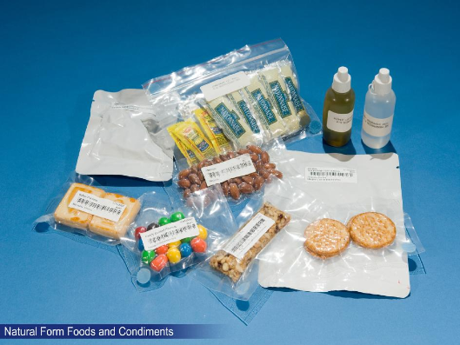
- The picture illustrates that food products can be of different colors, shapes, sizes and weights.
- The application will be fully flexible on the supported food products. Any new food product will be easily added to the application and stored locally on the iPad devices.
- Please refer to the client-provided documents on the food product examples (in “client_docs” folder).
- Please note, the beverages are specially packed to not allow pouring fluids to the ISS air (and floating) due to microgravity.
- On the Food Photo page, the “Download” and “Delete” buttons should appear grayed out until a picture is selected.
- A photo of the example beverages is shown below:
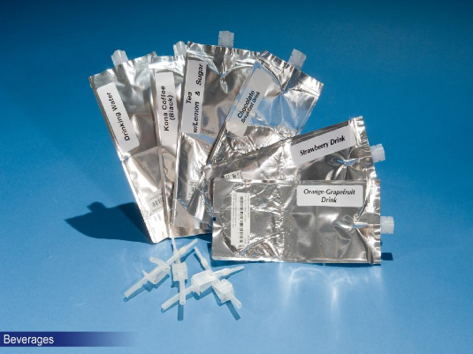
- The pictures above are from here: http://www.topcoder.com/iss/fit/
- The example picture of the meal is shown below. It is from here (larger image is available): http://www.universetoday.com/93818/dream-job-go-to-hawaii-and-eat-astronaut-food/
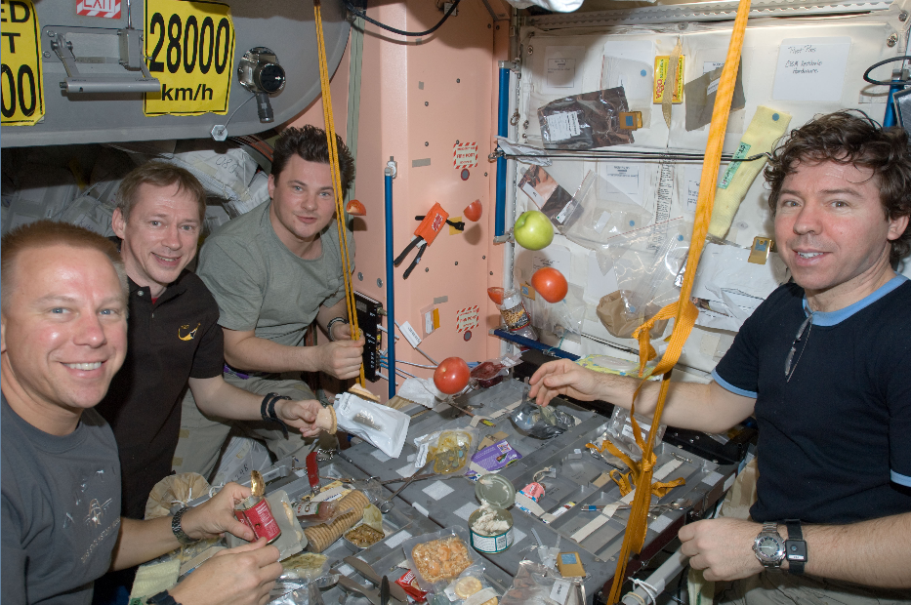

Record Voice
- The user will just say the name of the consumed food product to the iPad microphone.
- When voice is recorded, the voice file will be saved and stored (with the ability to be downloaded) in case the client needs to refer back to them.

Take Pictures
- The user will scan a picture of the being consumed food product by iPad front or rear camera.
- The user will be asked to enter the name of the food product.
- This data input method will be used not only for entering consumed data, but also for updating existing food data and entering new (and ad-hoc) data.
- When a photo is taken of a food item, the image will be saved and stored (with the ability to be downloaded) in case the client needs to refer back to them.

Scan Bar Codes
- The user will point the front or rear camera of iPad to the bar codes on the food/beverage for very precise and fast recognition and matching of the product against the existing foods/beverages.
- The application will scan the bar code, recognize it and match the bar codes with the existing products in the system.
- This data input method will be used not only for entering consumed data, but also for updating existing food data and entering new (and ad-hoc) data.

Manually Select Data from Groups
- The user will easily select the consumed food product through the groups of foods/beverages on the screen.
- There will be a special visually appealing GUI like on the supermarket touch-screen scales, so the user will be able to very quickly and efficiently locate the needed food/beverage product.
- Please refer to the chapter 3.1 for the detailed explanation of this input method (with pictures and discussion).
- This data input method will be used not only for entering consumed data, but also for updating existing food data and adding new (and ad-hoc) data. Though actual entering of a new data should be performed with some other method (like simple typing on a virtual touch screen keyboard).

Manually Enter Text Data
- It will be possible to just manually enter the text name of the food on the touch screen.
- Auto complete feature will significantly improve speed and correctness of this input method.
- This data input method will be used not only for entering consumed data, but also for updating existing food data and entering new (and ad-hoc) data.

Configure Application
- Under the settings, the user will have the option to never be logged out automatically, or to automatically log out after 5 minutes of inactivity.
- The user will be able to configure filter setting, which has 2 options: Use Default Filter and User Last Used Filter.

Administrator Functionality

Manage User Profiles
- The application will display list of all the users (pictures of users are suggested for displaying).
- The Administrator will be able to open a profile of any user and update it in the same way as the regular user manages his/her own account.
- Additionally, the Administrator will freely add new user accounts to the system and remove existing user accounts (together with all the data for that user – it will be very helpful to free that data after the end of that astronaut mission on the ISS).
- The Administrator will also be able to assign an Administrator user role to (or un-assign it from) the other user account.

Access All Application Data
- The Administrator will view all the data of all the users.
- There will be a displayed list of users.
- The Administrator will choose the needed user from the list and then view all the food intake information of the user (like on the calendar, or on the list with detailed and summary information).
  - This includes the ability to download the photos of food items or audio clips taken by the user.

System Functionality

Share Data through Multiple iPads
- The application will automatically share entered/updated/removed data through all the dedicated iPads on the ISS.
- the application will automatically combine all the data entered/modified from all the iPads and deliver that combined data through all the dedicated iPads on the ISS.
- As a result, the users will work with any of the dedicated iPads and always get up-to-date information on the existing foods/beverages and their food intakes.

Persist Application Data on Shared File Server
- There will be a special shared file server, so the application will persist data on it.
- The server will be mostly used for storing output MS Excel files with food consumption data for the downlink, and for input control files from the uplink.
- The application will persist some of its data on the shared file server (up-to the Architect). It will be used for easier communication and sharing of newly added/changed data between multiple iPads and the amount of persisted data will not be large, because not much information is entered to the application during the week.
- After the week, most newly entered information becomes almost constant and already transferred to the iPads, so that data will be removed from the shared file server.

Generate Output Tracking File
- The system will automatically generate output tracking file (in MS Excel format) with collected food/beverages intakes for astronauts.
- The file will be generated according to he food consumption data entered by the astronauts.
- The file will be generated in the predefined format and data structure (from the previous FFQ application).
- The information about which iPads were used for entering food tracking records should be also added to the output file, so the results will be collated on the Earth.

Send Food Data by Downlink
- The generated output file will be sent to the downlink through a special folder on a shared file server.
- The application will simply store the generated output file to the dedicated folder on the shared file server and that file will be automatically sent to Earth by the file server.

Receive Control Data by Uplink
- The system will receive control data files from the uplink through a special folder on a shared file server.
- The incoming files from the Earth laboratory are automatically delivered to that uplink folder on the shared file server on a regular basis.
- The application will scan a special configured uplink folder on the shared file server for the new incoming files.
- That incoming file will have control data, configuration and special commands for the application.

Process Commands from Uplink File
- The application will parse the received file and perform commands accordingly.
- The application will add/update/remove existing food/beverages data, add/update/remove user profiles, assign/un-assign Administrator user roles, update application configuration according to the information received from the Earth in those control files.
- If a crewmember enters a food that is not in the database, the application will have the ability to uplink nutrient content to the program and have that person’s file auto-update with the added nutrient info.
- The food categories in the application will have the ability to be modified by the uplink.

Delete Processed Files from File Server
- The application will automatically delete all the already processed files from the shared file server.
- The disk space of the shared file server is a very important resource on the ISS, so the application should immediately remove own input/output files that are no more needed.

Recognize Bar Codes
- The system recognizes the product bar codes instead of standard textual input of food information.
- Selection the efficient bar codes recognition algorithm and library is up-to the Architect. Some proper bar codes format should be chosen by the Architect.
- The algorithm will be performed right on iPad device on the ISS, so there will be NO need to send large amounts of graphical data for significantly delayed offline processing to Earth.

Perform Logging
- The system will automatically log all the errors, exceptions, debug and warning information during the mobile application execution. It is needed for further maintenance, support and improvement of the mobile application.
- The logged information must not contain user credentials.
- Logging will be performed to some sort of the logging system and the information will be stored to log files on the mobile device.

Perform Auto Save
- The system will automatically save the data entered by the user in case the user is away for >5 min and forgets to log out.
- The application will also need to auto save with each change.
- The data currently entered by the user will be saved.

Calculate Basic Nutrient Content
- The system will need to calculate some basic nutrition content to display to the user on the summary page.
- The calculation will be based on the limited nutrient content information available.
  - NOTE: Full nutritional analysis is still out of scope and will be done externally for this iPad app.
- The calculated basic nutrition content will be displayed to the user on the Summary page, next to food name.
  - The system will display calories and sodium content of the item, and either at the bottom of that screen, or on another screen after pressing a button at the bottom of the screen to calculate nutrition, to display daily total calories, sodium, and fluid consumption.
- Below the calculated values there must be a note that explains that these are preliminary calculations only, and may not include all food items (Official results pending detailed report analysis).

Security Requirements
This section documents, at a high level, the basic security requirements of the application. For example, does the system require the user to log in? Should the user’s identity be authenticated on just this system, or against a central authority? Are there any special or unusual security requirements, like fingerprint scanning?

The system will require users to register to the application and login

Non-registered users will have just a few features in the application (like help, registration)

There was no central authority of accounts, so the user will create his/her accounts through the application. It will be also possible to define user account and user roles through the control file received through uplink.

The application will not need a security system or to verify user credentials. Users can login simply by tapping their photo on the login screen (no password). Any user can login as an Admin user if needed.

The user personal information has to be properly secured, because food intake data is considered as private medical information. The Architect needs to select a proper solution.

Performance Requirements
Performance Requirements for the application are defined at a high level below. If there are specific requirements for specific features to perform at a quantifiable level, they too are listed below. These requirements will be developed in more detail when the Requirements Specification is written, in a later phase.

The expected maximum count of unique users is 6 (but likely 3)

The expected maximum count of concurrent users is 1 (this is a native mobile iPad application)

There are 3 iPads on the ISS. They can be used interchangeably by astronauts.

There can be concurrency in data synchronization process between multiple iPads. And multiple iPads can concurrently communicate with the shared file server.

The mobile iPad application should be fast, responsive and easy to use, so the limit of maximum 15 minutes per week for entering food intake data by a single astronaut will NOT be exceeded. Though, some leeway can be given if data capture takes more time.

This is a native application for a mobile device, so availability and uptime metrics are not applicable.

Data Migration
Data Migration describes the data that needs to be moved from an older or external system to the new system, in order for it to operate at launch. Migration also includes data that must be transferred from the new system to another external system. Any data migration requirements are listed below.

No Data Migration, but Re-use of Existing Food Data
There will be no migration of the data. The information about the existing food/beverage products can be just manually entered to the application or delivered through the uplink file from the Earth laboratory.

